**Anglia Ruskin University**

**MOD002619**

**Web Programming**

**SID:1503126**

Contents

1.0 Project Overview 3

1.1 Introduction 3

1.2 Detailed Specification 3

2.0 Implementation 740 4

2.1 Page Styling 4

2.2 How information will be stored 5

2.2.1 Users table 5

2.2.2 Role table 6

2.2.3 Items table 6

2.2.4 Authors table 6

2.2.5 Searches table 6

2.3 User Permissions 7

2.4 Security 8

3.0 Creating a new User 151 9

3.1 Students creating a user account 9

3.2 Librarians creating a new user. 10

3.3 Administrators creating New Users. 11

3.4 Viewing Users 11

4.0 Searching for Items or Authors. 115 12

5.0 Technical Design implementation 326 14

5.1 Security 14

5.2 Searching 15

5.3 Restricting Menu Access 15

6.0 Testing 164 16

7.0 Reflective Review. 154 17

# Project Overview.

## 1.1 Introduction

This report documents the new Library system that has been implemented into the University. Currently the library was using a paper based system which was difficult to manage moving to a computer based system will see greater efficiency for looking for and managing books.

The focus of this document is to go into technical detail how the library system works with potential improvements and shortfalls of the current system.

## 1.2 Detailed Specification

When the new library system was in the design phase, a specification was created with a list of features that must be achieved.

* A login system, with user types of ‘Student’, ‘Librarian’ and ‘Admin’ which must have a secure login system and user permission restrictions.
* A ‘Student’ must be allowed to login, view all ‘Items’ and authors but must not be allowed to edit or remove details, but must have the facility to search for an ‘Item’, and view its availability within the library.
* A ‘Librarian’ or ‘Admin’, must have full permissions to manage all facilities in the library, such as adding new ‘Authors’ and ‘Items’. They must also be able to change any ‘Items’ availability.

# Implementation.

## 2.1 Page Styling

When designing the new Library website a basic colour scheme of Blue and Gold were selected. A basic design was favoured due to simplicity and being able to show valuable information to the users in a clear way. The top banner would always show the user that they are accessing the University Library with a clear telephone number that can be used for contact purposes.



## 2.2 How information will be stored

A simple database has been implemented which stores all information regarding the University’s Library system.

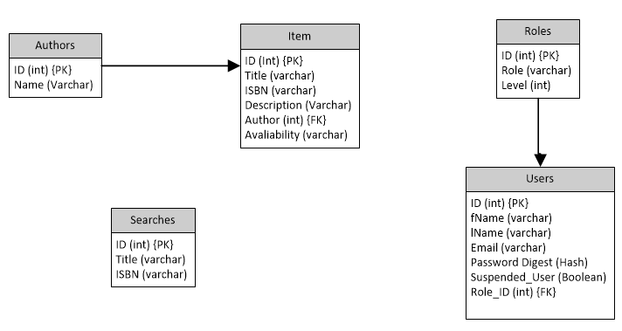An entity relationship diagram can be seen below, which outlines the database tables and what can be found in each table and the relationship’s.

### 2.2.1 Users table

The Users table will hold information on all of the users found on the system. The users passwords will be secured using an MD5 hash, ensuring that passwords are not kept as plaintext. A user account can be suspended, and in future versions of the library system a suspended user will not be granted access to the system. Validation has been created so that each entry must have a first name, last name, email and password. To avoid duplicate accounts for users, each email address will be automatically changed to lower case and then must be unique. No first or last name can be more than 50 characters long.

### 2.2.2 Role table

The users role can be found from the Role table, including a role table allows for potential expandability if and when required. The role is entered as a foreign key in the user table allowing a user set permissions, currently the role is being used using the Primary Key ID of the role, in the future this should be changed to the Level.

### 2.2.3 Items table

Currently the new University library system is only capable of storing book information, but future versions of the library system should be able to handle additional items such as DVD’s and academic journal articles that should be available to students.

Each item will be required to have a name, ISBN, description, availability and author which is linked via a foreign key to the authors table.

Each item must be entered individually with its own ID, so that in a later release of the system the librarian’s and administrators will be able to see which unique book has been lent to which student. Currently all students can see the availability of items, but librarians must change the availability status when an item an item is withdrawn.

### 2.2.4 Authors table

As one author often writes many books, each author has their own entry in a database which must be linked to an item. Validation has been entered to avoid duplicate authors.

### 2.2.5 Searches table

The searches table is currently not in use. During development an ‘Advanced Search’ was designed where a complex search could be created. It was decided that each search could then be stored in a database table showing trends and most commonly searched items.

## 2.3 User Permissions

There are three permission levels on the University Library System.

Student: Students can login, view and search for items and authors. They can view an items description and availability.

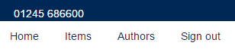

Librarian: A librarian can create new student accounts, they are also able to add new authors and items. When a student is withdrawing an item the librarian must change the availability status. If needed, librarians can edit and remove, authors, items or users.



Admin: Administrators have full access to the system. When creating a new user, the administrator must choose the permission level between admin, librarian and student. Administrators can also perform the same tasks as a librarian.



## 2.4 Security

One of the specifications of the new Library system is that it must be secure, only allowing valid users access.

To achieve this, everyone wishing to access the system must obtain a user account, students are able to sign themselves up from the website homepage. Once logged in each user will be granted a unique session, which will be destroyed when the user logs out.

Each user is stored in a simple database table (detailed in section 2.2.1) where the users passwords are stored using an MD5 hash. This has been achieved by using the Bcrypt gem to ensure maximum security.

User permissions have also been implemented to ensure that the website has the necessary restrictions. Students for example, are only able to view pages regarding authors and items, and if they attempt to navigate to a page they do not have access they will receive an error message (below).

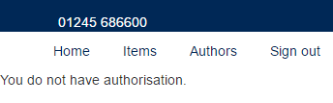

# Creating a new User.

This chapter outlines how new user accounts can be created on the system, from each permission level’s point of view.

## 3.1 Students creating a user account

Before a student can access the system they must create a user account. From the sign in page a user must select the “Sign up now!” link.

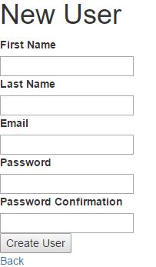From there, the user is shown the New User form which they must fill in, following the validation rules set.

If a user fails to follow the validation rules they will be shown an error message (below).

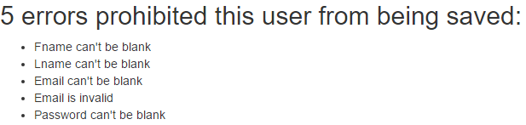

## 3.2 Librarians creating a new user.

A librarian can create new student accounts, to do this they must navigate to the User page and from there click the ‘New User’ link.

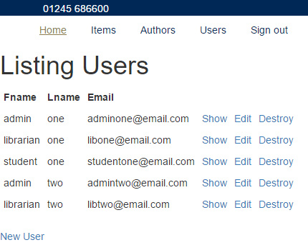

Once the Librarian has clicked on the ‘New User’ link they are presented with the standard form that students are shown.

## 3.3 Administrators creating New Users.

An administrator has the permissions to create accounts for all roles. To do this the Administrator must navigate the same way a Librarian does, but Administrators are presented with a different form to complete that include the roles option and suspend user option.

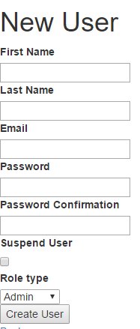

## 3.4 Viewing Users

Administrators and Librarians will be able to view, edit and destroy users. They will be shown a Users tab on the main menu when the log in.

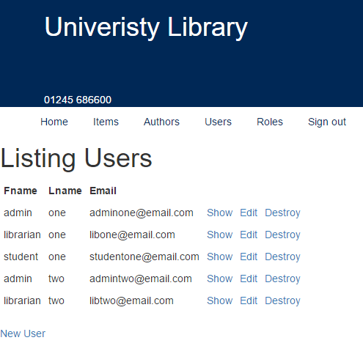

# Searching for Items or Authors.

In the specification it was desired that a search function was added due to the large number of books that the university has. Users are able to search through items using the title, and search for authors by name.

An advanced search page has been designed where users are able to search for an item by its ISBN mixed its title or author. This functionality has not been fully implemented in this version.

When in either the Item or Author page a user will be presented with a search box, where they can enter any item title, or author name. The search box will search the entire database table for any search result that is like what the user has entered.

Unfortunately, there is a bug in the system where the search does not work first time, the user will be forced to refresh the page and then the search will complete successfully.

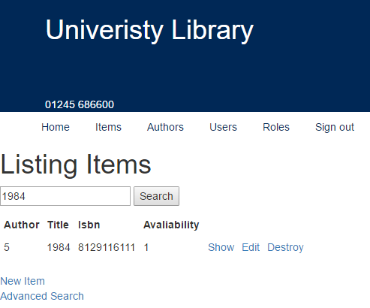

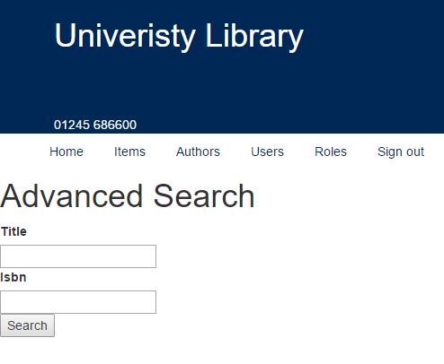When users attempt to complete an Advanced search they can enter either the Title or the ISBN, but the search will be unsuccessful.

The same search functionality can be found for the Authors. As can be seen in the screenshot below, the user only entered “Jan” into the search box but the system was able to find “Jane Austen”.

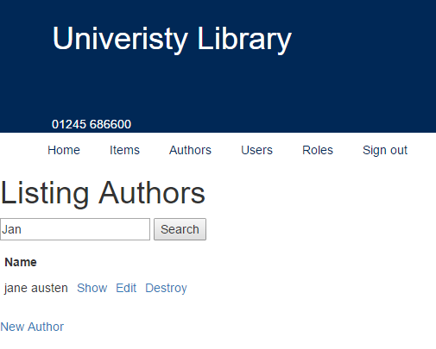

# Technical Design implementation.

This section of the report goes into further technical detail of how certain aspects of the specification have been met and the code that implemented.

## 5.1 Security

Security was a major area of focus when building the library system, it was important that all data is secure and access restricted.

As discussed in section 2.2.1 when creating a new user certain validation points have been entered ensuring that the data entered by the user is genuine. The code below, shows how each entry must include required parameters.

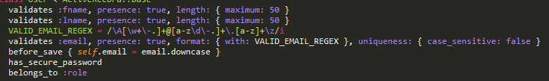

To ensure that passwords are kept securely the BCrypt gem was used, as explained in section 2.4.



Restricting user access to certain webpages by simply removing the option from the menu bar can restrict many users from access, however users are still able to gain access by entering the full address into the URL bar.

To ensure that all users are logged in and have the correct permissions security methods have been created.

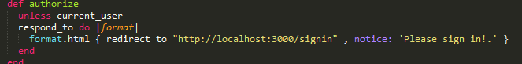The method below simply ensures that all users are logged in, if the system detects that a user is not logged in they will be redirected to the homepage.

Additional security methods have been written to limit user access depending on their permission levels (as seen below left).

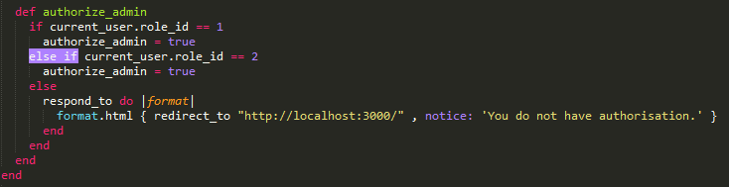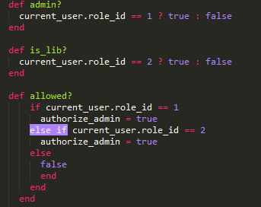

A check called ‘authorize_admin’ has been created which checks if the current users permission is either a librarian or administrator, if they are not they are returned to the homepage.

When on a page controller the “before filter” was used to implement such methods.



## 5.2 Searching

The following code was inserted which allowed the search functionality, this was modified to suit which search it was completing such as Item or Author.

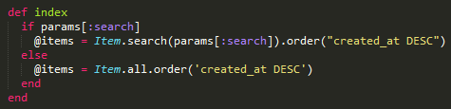

## 5.3 Restricting Menu Access

To restrict Menu access, an if statement was entered into the main application layout file. It asked if the current user was signed in and authorised to view the options.



# Testing.

Throughout the implementation of the University Library System small tests were taking place. No formal testing log was held, but steps were taken to ensure that proper test were taking place using the flow diagram in section 6.1.

To aid in the testing, test user accounts, items and authors were created, these were used to ensure that permission were working correctly and any changes could be seen throughout the entire application.

## 6.1 Testing Flow Diagram



# Reflective Review.

I found this assignment to be very difficult to complete but rewarding. It was difficult learning several new languages simultaneously as I had never engaged in any web development before, so even simple HTML code required research.

Since I have never completed work in web development before this module was a huge learning curve. I feel like understanding the MVC architecture really helped my understanding on how web frameworks function. I still feel like I have very basic knowledge in Ruby, HTML and CSS but with this basic knowledge I feel I was able to build a basic usable system.

I found working with Ruby to be difficult at times as so much code seemed to be automatically generated I didn’t always know what pieces of codes functions were.

I am particularly proud in the permissions implementation, and restricting user access. I am happy with how the website looks, I think it provides a simple easy to understand user interface.

I would like to broaden my knowledge further into front end development, working on how to make a website look exciting and professional. I would also really enjoy looking into Ruby on Rails and other frameworks to see what I am able to achieve.